Lab - Exploring DNS Traffic

Objectives
Part 1: Capture DNS Traffic
Part 2: Explore DNS Query Traffic
Part 3: Explore DNS Response Traffic

Background / Scenario
Wireshark is an open source packet capture and analysis tool. Wireshark gives a detailed breakdown of the network protocol stack. Wireshark allows you to filter traffic for network troubleshooting, investigate security issues, and analyze network protocols. Because Wireshark allows you to view the packet details, it can be used as a reconnaissance tool for an attacker.
In this lab, you will install Wireshark and use Wireshark to filter for DNS packets and view the details of both DNS query and response packets.

Required Resources
- 1 PC with internet access and Wireshark installed

Instructions

Capture DNS Traffic

Download and install Wireshark.
      - Download the latest stable version of Wireshark from www.wireshark.org. Choose the software version you need based on your PC’s architecture and operating system.
      - Follow the on-screen instructions to install Wireshark. If you are prompted to install USBPcap, do NOT install USBPcap for normal traffic capture. USBPcap is experimental, and it could cause USB problems on your PC.

Capture DNS traffic.
      - Start Wireshark. Select an active interface with traffic for packet capture.
      - Clear the DNS cache.
        - In Windows, enter ipconfig /flushdns in Command Prompt.
        - For the majority of Linux distributions, one of the following utilities is used for DNS caching: Systemd -Resolved, DNSMasq, and NSCD. If your Linux distribution does not use one of the listed utilities, please perform an internet search for the DNS caching utility for your Linux distribution.
          - Identify the utility used in your Linux distribution by checking the status:
Systemd-Resolved: systemctl status systemd-resolved.service
DNSMasq: systemctl status dnsmasq.service
NSCD: systemctl status nscd.service
          - If you are using system-resolved, enter systemd-resolve --flush-caches to flush the cache for Systemd-Resolved before restarting the service. The following commands restart the associated service using elevated privileges:
Systemd-Resolved: sudo systemctl restart systemd-resolved.service
DNSMasq: sudo systemctl restart dnsmasq.service
NSCD: sudo systemctl restart nscd.service
        - For the macOS, enter sudo killall -HUP mDNSResponder to clear the DNS cache in the Terminal. Perform an internet search for the commands to clear the DNS cache for an older OS.
      - At a command prompt or terminal, type nslookup enter the interactive mode.
      - Enter the domain name of a website. The domain name www.cisco.com is used in this example.
      - Type exit when finished. Close the command prompt.
      - Click Stop capturing packets to stop the Wireshark capture.

Explore DNS Query Traffic
      - Observe the traffic captured in the Wireshark Packet List pane. Enter udp.port == 53 in the filter box and click the arrow (or press enter) to display only DNS packets. Note: The provided screenshots are just examples. Your output maybe slightly different.
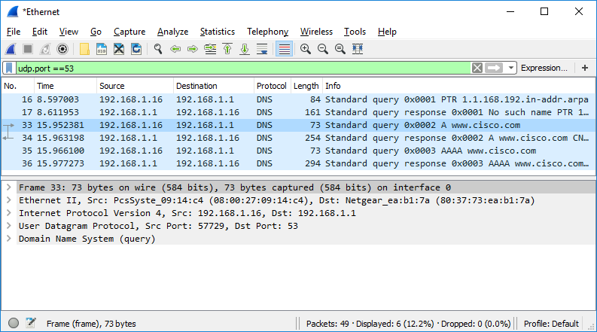
      - Select the DNS packet contains Standard query and A www.cisco.com in the Info column.
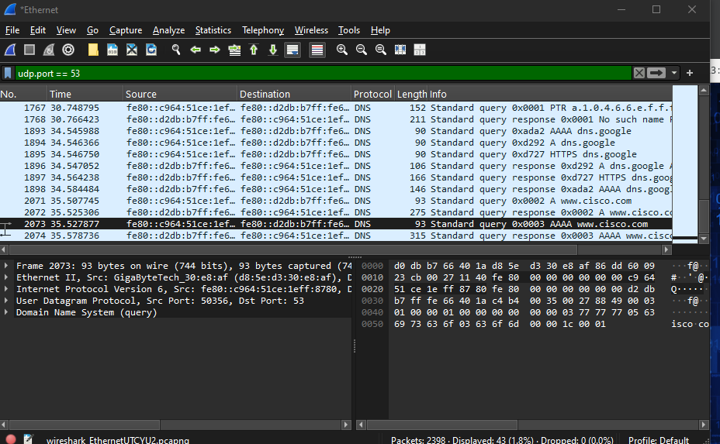
      - In the Packet Details pane, notice this packet has Ethernet II, Internet Protocol Version 4, User Datagram Protocol and Domain Name System (query).

      - Expand Ethernet II to view the details. Observe the source and destination fields.
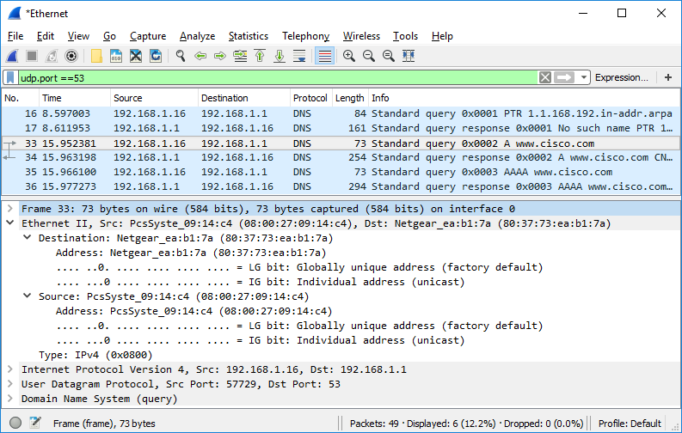
What are the source and destination MAC addresses? Which network interfaces are these MAC addresses associated with?
Type your answ ers here.
The source will be coming from my computer and destination is the website destination where it responds
      - Expand Internet Protocol Version 4. Observe the source and destination IPv4 addresses.
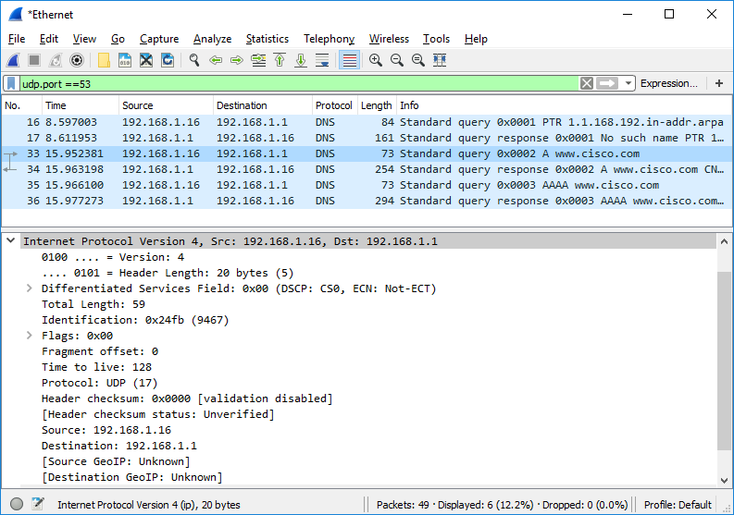

Question:
What are the source and destination IP addresses? Which network interfaces are these IP addresses associated with?
Type your answer 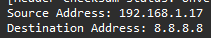s the source address is my computer and is communicating with www.cisco.com ip address
The re.
      - Expand the User Datagram Protocol. Observe the source and destination ports.
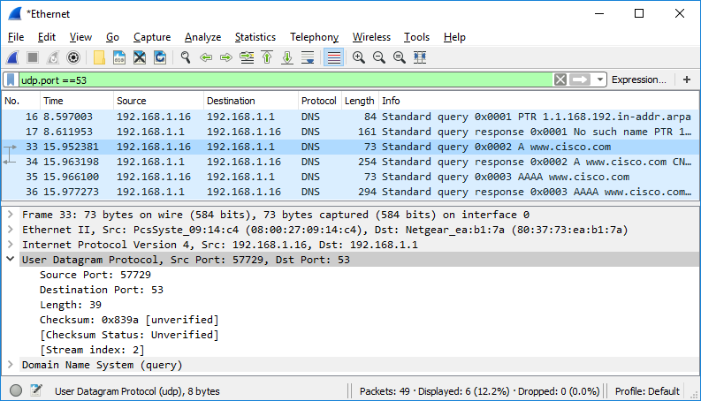

Question:
What are the source and destination ports? What is the default DNS port number?
Type your answers here.
      - Determine the IP and MAC address of the PC.
        - In a Windows command prompt, enter arp –a and ipconfig /all to record the MAC and IP addresses of the PC.
        - For Linux and macOS PC, enter ifconfig or ip address in a terminal.

Question:
Compare the MAC and IP addresses in the Wireshark results to the IP and MAC addresses. What is your observation?
Type your answers heThethe ip addresses and mac addresses compared to the wireshark are identical to each other. My observation is that wireshark will display my computers communication to the cisco website and will return information about it
      - Expand Domain Name System (query) in the Packet Details pane. Then expand the Flags and Queries.
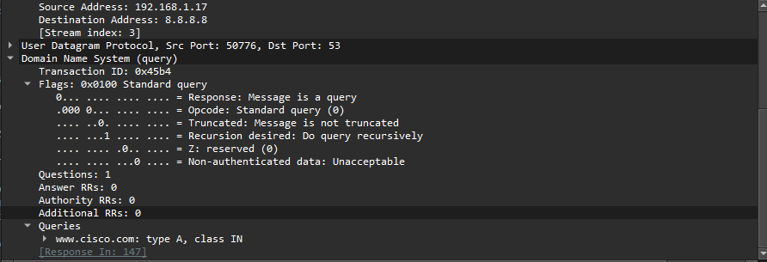
      - Observe the results. The flag is set to do the query recursively to query for the IP address to www.cisco.com.
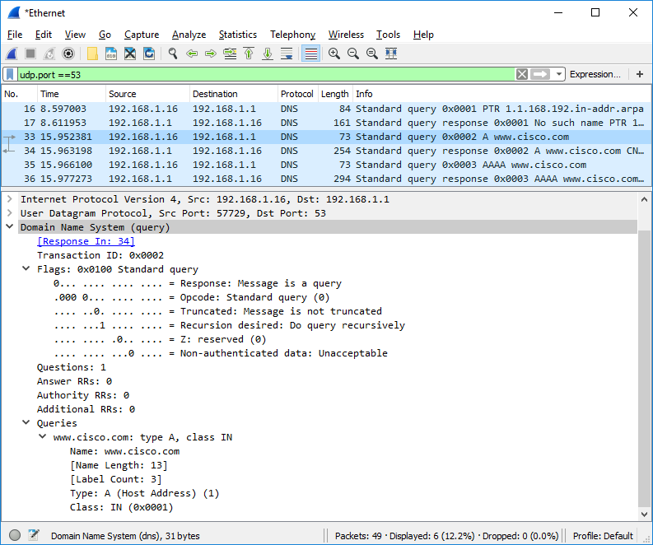

Explore DNS Response Traffic
      - Select the corresponding response DNS packet has Standard query response and A www.cisco.com in the Info column.
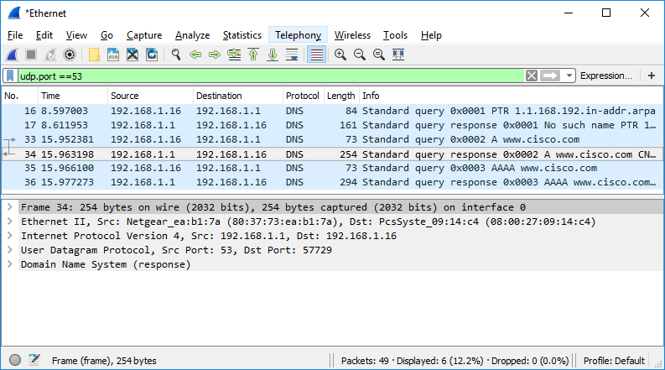

Question:
What are the source and destination MAC and IP addresses and port numbers? How do they compare to the addresses in the DNS query packets?
Type your answers here.
      - Expand Domain Name System (response). Then expand the Flags, Queries, and Answers.
      - Observe the results.

Question:
Can the DNS server do recursive queries?
Yes the dns can do recursive queries
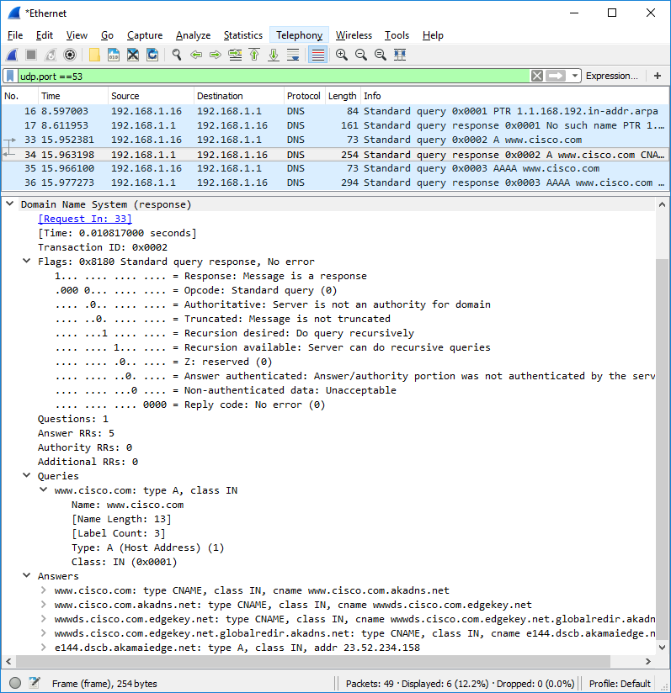
      - Observe the CNAME and A records in the Answers details.

Question:
How do the results compare to nslookup results?
Type your answers here.in wireshark it will show more results

Reflection
  - From the Wireshark results, what else can you learn about the network when you remove the filter?
Type your answers hyou you can learn about the ARP and TCP protocols and QUIC and MDNSand QUIC
  - How can an attacker use Wireshark to compromise your network security?
Type your answers here.when using wireshark an attacker can do packet sniffing and eacesdropping and are able to do man in the middle attacks also session hijacking just from Wireshark
End of document

